**Assessing Geographic Bias in Bike Share Systems**

Do bike share systems equitably serve all parts of the city? To answer this question, I pulled data on the locations of bike share stations for 4 cities from their respective open data portals. I then computed what I call a tract reporting bias for each tract in the cities.

The tract reporting bias is the percentage of data (in this case bike share stations) originating from a tract minus the proportion of a city’s population originating in that tract*.* It is meant to be a crude measure of how ever and underrepresented certain tracts of the city are in terms of bike share station coverage.

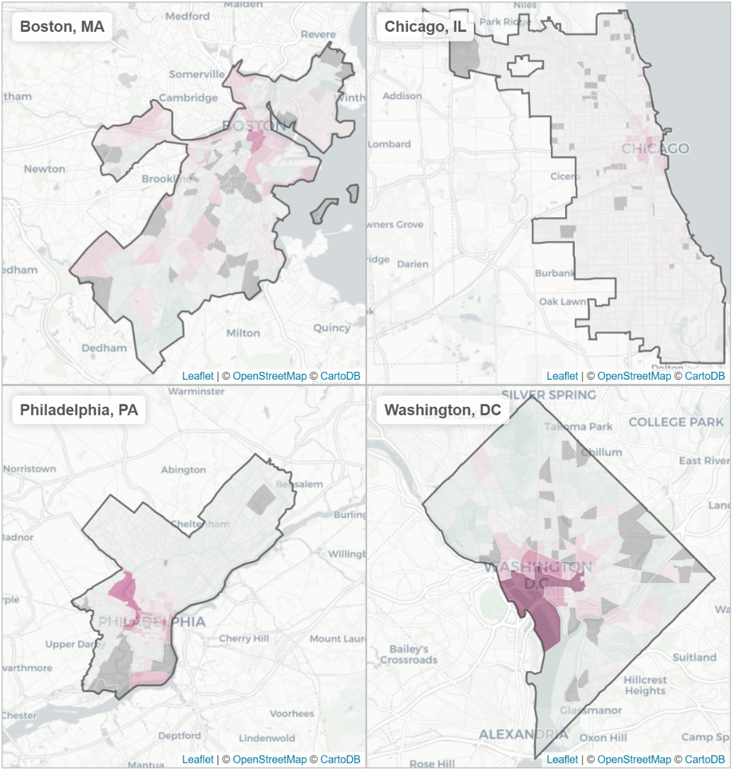**Figure 1: Bike Share Stations: Geographic Bias across Cities**

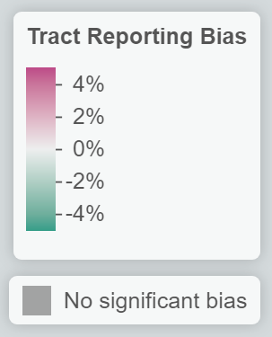

**Source:** Data from municipal open data portals and ACS 5 year (2011-2016) Survey

**Notes:** Built with leaflet.js